A Depth Model for Context Specific Risk Assessment of Chinook Salmon Bycatch in the Gulf of Alaska

Marcel Gietzmann-Sanders, Michael Courtney, Andrew Seitz, Curry Cunningham

Abstract

Bycatch of Chinook salmon (Oncorhynchus tshawytscha) in the Gulf of Alaska walleye pollock (Gadus chalcogrammus) fishery poses both conservation and management challenges. While fleet communication and excluder devices have improved mitigation, effective reduction ultimately depends on anticipating overlap—especially near the seafloor where pollock are targeted. To support context-specific bycatch strategies, we developed a probabilistic deep learning model that predicts Chinook salmon depth occupancy using fisheries-independent telemetry data and environmental, temporal, and spatial covariates. The model resolved fine-scale patterns in diel and seasonal behavior and accurately recaptured known depth-use trends, while also revealing new dynamics—such as a winter-to-spring reversal in diel patterns and shifts aligned with regional productivity cycles. By generating spatiotemporal predictions of occupancy throughout the water column, the model enables dynamic assessment of bycatch risk and highlights when and where overlap with trawl gear is most likely. These findings demonstrate how behavioral models can augment existing mitigation tools and underscore the need for broader telemetry coverage to capture the full behavioral gradients that shape Chinook-fishery interactions.

Introduction

Bycatch — the capture of non-target organisms — is a persistent issue in many fisheries (Davies, 2009; Hall, 2000). While it first gained public attention through incidental take of charismatic megafauna (Hall, 2000), subsequent research has illuminated a range of concerns. These include the waste of edible protein (Hall, 2000; Zeller., 2018), conflicts between fisheries targeting different species (Lomeli, 2021; NPFMC, 2022), increased extinction risk for vulnerable species (Wallace, 2013; D’Agrosa, 2000), trophic disruption (Estes., 2011), and destabilization of population dynamics (Hall, 2000). As a result, considerable attention has been directed toward reducing bycatch.

Of particular concern in the state of Alaska is the incidental capture of Chinook salmon (Oncorhynchus tshawytscha) in the walleye pollock (Gadus chalcogrammus) fishery (NPFMC, 2022). The walleye pollock fishery is the largest in the United States by volume (NPFMC, 2022). The retained 2020 catch in just the Gulf of Alaska (GOA) totaled 107,000 metric tons and had a first wholesale value of $70.6 million (Monnahan, 2021). Within this fishery, Chinook salmon bycatch is considered prohibited species catch (PSC) meaning it is bycatch that cannot be retained or sold. PSC allowances are granted to the fishery but if those allowances are exceeded, the fishery is shut down regardless of the remaining allowable catch (NPFMC, 2024). For the Gulf of Alaska these limits are set at 18,316 fish for the Central GOA and 6,684 for the Western GOA, (Amendment 93) with limited provisions for reallocation of unused PSC between sectors (Amendment 103; NPFMC, 2024). As recently as 2024 two boats accidentally brought in enough Chinook salmon over a single weekend to exceed these allowances (Mapes, 2024). With such limited allowances, bycatch avoidance has been an area of active development.

Of those developments, one of the most promising has been cooperative data-sharing amongst fishers (NPMFC, 2022). Through such programs fishers can dynamically adjust their response to bycatch risk based on up-to-date information shared through the whole fleet. This information is also used to setup short-term closures in high-bycatch zones (NPFMC, 2022) – yet another tool in the dynamic ocean management toolbox that draws its power from near real-time, local information on bycatch risk (Squires, 2021). However, improved understanding of the spatial ecology of Chinook salmon while at sea, including their habitat and depth preferences may improve the efficacy of bycatch mitigation actions by identifying high risk zones.

Adding information on depth occupancy to this toolbox could prove fruitful. Adult walleye pollock are largely demersal (Adams, 2009) (Duffy-Anderson, 2003) whereas Chinook salmon are very active in the water column (Courtney, 2019, 2021; Orsi, 1995). While Chinook salmon spend most of their time between 0 and 50m their overall observed range extends beyond 500m (Courtney, 2019, 2021). They also display flexible diel behaviors, sometimes reverse their movement patterns seasonally (Arostegui, 2017; Courtney, 2019, 2021), and seem to vary their depth occupancy in relation to temperature, productivity indicators, and current velocity (Freshwater, 2024; Orsi, 1995; Hinke, 2005). In contrast, while walleye pollock are known to exhibit diel patterns, (Adams, 2009; Miyashita, 2004) the majority of adult walleye pollock are primarily demersal – a pattern reinforced by the fact that the fishery targets them at or near the sea floor (Stratton, 2023). These differences suggest that bycatch risk could be further mitigated if localized and dynamic information on Chinook salmon depth occupancy was available.

A model of localized, Chinook salmon depth occupancy has not yet been built. Most studies on depth occupancy in Chinook salmon have focused on understanding the factors influencing depth as opposed to developing inferential tools for localized prediction (Freshwater, 2024). One exception was Freshwater et al., (2024) who trained a model that leveraged localized environmental and temporal covariates to predict expected depth for Chinook salmon along the coast of Washington and British Columbia. However, to assess relative risk with specific depth range, a model would need to estimate the distribution of fish over the entire the water column. Arostegui et al. (2017) did produce such a distributional model but only used season and day/night as features preventing the model from being amenable to localized and dynamic predictions. Combining these two approaches remains an open opportunity for Chinook salmon.

Therefore, our goal is to build a Chinook salmon depth model capable of local prediction and show it can inform bycatch mitigation strategies. We will do this in three steps. First, we will build a model that leverages environmental and temporal context to predict the relative likelihood of depth-bin occupancy by Chinook salmon throughout the water column. Considered context will include oceanographic, biochemical, seasonal, and diurnal characteristics. Second, we will evaluate the model’s predictions against observed depth occupancy and compare it to patterns observed in past research. Finally, we will generate a year's worth of predictions over the Gulf of Alaska and illustrate how those predictions can inform the selection of places and times where there is lower risk of Chinook occupancy near the sea floor.

Methods

Overview of Model Training

To build a model that uses environmental and temporal context to predict fish occupation of discrete depth bins, we applied probabilistic deep learning (Durr, 2020) and framed the problem as a classification of fish occupancy within those bins. As such, the model was trained over a dataset where each sample in that dataset corresponds to one fish at a specific location and time and that fish's "classification" is defined as the depth bin it was observed to occupy. Features for each sample are derived from the environmental and/or temporal context associated with the depth bins at that position. Model training then aimed to reduce categorical cross entropy – a loss function whose negative measures the likelihood of the observed data given the predictions. Deep learning was selected as such models can learn highly non-linear, combinatorial patterns (Durr, 2020).

Broadly, models were built using the following steps. First, we retrieved Chinook salmon movement tracks from prior research in the Gulf of Alaska and Eastern Bering Sea (Seitz, 2024). The position and depth data were then transformed to provide samples for a classification model and split into training and validation sets. Environmental data was retrieved from the Copernicus Marine Service and temporal data derived from “ephem” and “suntimes” packages in Python. These data were then aggregated, scaled, and joined to the movement tracks to provide model features. Given the high dimensionality of this feature space, a novel dimensionality reduction technique was applied. Models were trained over a variety of increasingly comprehensive feature sets and the final model selected using loss over the validation set. The following paragraphs describe each of these steps in detail.

Details of Model Training

Chinook salmon movement tracks (Seitz, 2024), consisting of daily estimated positions and depths were used to train and test our models. Fish (62-100cm fork length) were caught and tagged near Dutch Harbor, AK and Chignik, AK (n=tbd), Homer, AK (n=tbd), Kodiak, AK (n=tbd), Yakutat, AK (n=tbd), Sitka, AK (n=tbd), and in the Eastern Bering Sea (n=tbd). In the EBS they were caught via midwater trawl or by hook whereas all other catches happened by hook and line (Seitz, 2024). Fish were then monitored using pop-up satellite archival tags that collect temperature, ambient light intensity, and depth information at specified (sub day) intervals during deployment and then release from the fish, surface, and transmit data over satellite. While the data is sampled at a sub-minute interval, the central tendency of depth occupancy is summarized per 15-minute period before being uploaded due to limited battery life. If the tag is recovered, the full dataset is available. To obtain location estimates, the data from the tag is passed through a proprietary hidden Markov model from Wildlife Computers that uses the tag’s data to estimate the likely paths taken by the fish during tag deployment (Wildlife Computers, 2025). An estimate of location for each day can then be derived as the central tendency of those paths on a particular day. In total 7,532 observation days were collected across the fish. This data was especially well suited to our problem as it has the distinct advantages of being fisheries independent and giving a comprehensive view of depth occupancy throughout tag deployment no matter where the fish may go.

After collecting these tag tracks, observations were prepared for use in classification. To prevent over-representing the precision of the uploaded data, we sampled depth measurements from a normal distribution centered at the 15-minute depth summary with a standard deviation equal to 10% of the summary. We then assigned each sample to a depth bin. Depth bins were divided into increments of 25, 50, 75, 100, 150, 200, 250, 300, 400, and 500 meters. Each number indicates the upper bound of a bin and does not include depths from shallower bins. These depth bins were then normalized to a decimal between 0 and 1 with bin 25 corresponding to 0.1, 50 to 0.2, and so on. Finally, daily fish positions were aggregated to a fixed, hexagonal spatial grid - resolution 4 Uber H3 cells – in order to not over-represent the accuracy of the estimated positions.

Environmental conditions were derived from the Global Ocean Biogeochemistry Hindcast (10.48670/moi-00019) and Global Ocean Physics Reanalysis (10.48670/moi-00021) datasets provided by the E.U. Copernicus Marine Service. Data were drawn for each day between January 2013 and January 2023 in the Northern Pacific and values were aggregated to means per day, depth bin (see above), and Uber H3 cell at resolution 4. Environmental conditions chosen were chlorophyll, net primary production, nitrate, oxygen, phosphate, silicate, bottom elevation, mixed layer thickness, salinity, temperature, and north and easterly current velocity. These were then joined to the fish tracks on location and time.

Seasonality, lunar cycle, and diel features were derived using the datetimes associated with each sample along with the “ephem” and “suntimes” packages in Python for lunar and diel features respectively. In all cases, time was represented by taking the cycle in question, decomposing it to radians (0 at the beginning of the cycle and $2π$ at the end of the cycle), and then providing the sine and cosine of that feature to the models. Specifically, we constructed features indicating the number of days through the year (seasonality), progression through the day or night (cosines at 0 for sunrise and sunset, sines positive during the day and negative at night), and a final set of sines and cosines indicating progress through the lunar cycle.

To ensure all covariates were on the same scale, chlorophyll, net primary production, and mixed layer thickness were log scaled and then all environmental features were rescaled to be between 0 and 1. Given the range of sines and cosines are -1 to 1, no further normalization was needed for the temporal features.

Next, we made a modification to the typical probabilistic deep learning classification problem to reduce the dimensionality of our feature set. Given we have features for each depth bin, selecting N covariates results in a feature space of dimension 10N (N features across 10 depth bins). The 10x multiplier is an issue because the volume of data required to fit a model effectively can grow exponentially with the dimensionality of the feature space (Verleysen, 2005). Instead, we trained a model that predicts the log odds of occupancy in a specific depth bin. As only one depth bin’s features are needed in this model, our dimensionality drops to N. To train this model using categorical cross entropy we copied the log-odds model weights across all choices, passed depth bin in as a feature to each choice, and then passed the output of each model through a softmax activation layer whose weights are an untrainable identity matrix. This results in a model that still predicts probabilities per depth bin but has an effective dimensionality of N + 1 thereby increasing our odds of a good fit.

One issue with this approach is that with 10 depth bins most instances of the internal log-odds model are encouraged to report very low log-odds. This is equivalent to a class imbalance problem. We can rebalance the data by taking advantage of the fact that the log-odds of one choice is independent of the others. As a result, we can down-sample the number of choices in any decision to just two and achieve a balance the positive and negative classes. To ensure we capture the variety in choices, we then resampled the same decisions repeatedly to get different pairs of selected and unselected choices. We call this process contrast sampling as we are sampling selected vs unselected contrasts. In this specific case we decided on a random sample (with replacement) of 5,000 decisions per individual and 10 choices per decision. Over a validation/training split of 39/72 this resulted in 5,550,000 contrasts of which 3,600,000 were used in training and the rest in validation.

Models were implemented in Keras and trained for 100 epochs using a batch size of 200,000 and an Adam optimizer with a learning rate of 0.001. A grid search was performed over 2 and 3 hidden layers and 24 and 32 units per hidden layer and the model with the lowest validation over the contrast set was then selected. Amazon Web Service’s Batch Fargate service was used for compute and training was performed on instances with 2 vcpus and 4GB memory.

To facilitate feature selection and investigate the predictive power of different feature sets, several models were trained over feature sets of increasing complexity. All feature sets were subsets of the environmental and temporal features discussed above. The model with the lowest loss over the contrast validation set was selected as the final model. Then, starting from no features, the final model’s features were incrementally added to build additional models used to investigate the importance of each set of features. Each incremental feature was selected according to whichever caused the maximal drop in loss. For each of these models, in order to make comparisons, categorical cross entropy was computed over the validation and training sets for both the contrasts and the original decisions.

Evaluation of Model Predictions

To evaluate the model’s predictions against observed depth occupancy we summarized depth occupancy and predictions across each of the selected features. For seasonal effects we compared the proportion of fish in each depth bin per month in the validation set to the mean probability of fish in each depth bin as predicted by the model. To evaluate diurnal variation, we converted our sin_sun and cos_sun features back into radians and then computed the actual proportions of the fish at depths lower than 25m across months for both the training and validation sets. This was then compared to the mean probability of depth occupancy below 25m across the day as predicted by the model over the validation set. To illustrate the effect of salinity we looked at the predicted proportions of fish near the surface (<25m depth) when salinity was above and below 31.3ppt. As well as the change in model loss across month when adding the feature to the model.

Informing Bycatch Mitigation

To illustrate how the model predictions can guide mitigation of incidental capture near the seafloor we performed an inference over the Gulf of Alaska in the year of 2022 and then used the predictions to explore how our features drive risk.

First, in the same manner as described for model training, we built a dataset of model features that included each depth bin, over every single H3 resolution 4 cell, in each hour, over the full year of 2022 in the Gulf of Alaska and Eastern Bering Sea. This resulted in over 96 million entries. Using AWS Batch, we then ran model inference over these points to determine the likelihood associated with each of the entries. We then subset this data to just the GOA and removed entries where the average depth was greater than 600m as Chinook are rarely seen deeper than 500m.

Using this dataset we then explored the effect each of our features had on depth occupancy in the lowest depth bin available to each H3 cell. First, to look at seasonality, we computed the 5th percentile risk in the lowest depth bin per H3 cell across the months of February and August (winter and summer respectively). Then to better understand seasonal and diurnal variation we plotted the risk per depth bin across the entire year for one H3 cell (index=840ccebffffffff, lat=55.9N, lon=-158.2E) near Chignik where a number of the fish in this study were caught. To further understand variation in depth occupancy as a function of time of day, we computed, per H3 cell on August 15 and February 15, the average of our sin_sun feature with depth occupancy was below its 5th percentile for that day and H3 cell. Positive values of this aggregate indicate that occupancy is minimized during the day, negative values indicate a minimization at night.

Results

Model Evaluation

The model with the lowest validation loss (providing the highest likelihood of the data) included depth_bin, season, diel, and salinity as features (model D in Table 1). Starting from a null model with a loss of 1.740 (geometric mean probability [gmp] of 17.6%), adding depth_bin (model A) reduced the loss to 1.457 (gmp 23.3%). Including season (model B) brought it to 1.368 (gmp 25.5%), and adding the diel features (model C) lowered it again to 1.352 (gmp 25.9%). With salinity included (model D), the final validation loss reached 1.340 (gmp 26.2%).
Depth occupancy, as observed by the tags and predicted by the model, skewed toward relatively shallow water. Nearly half (46.4%) of the observations were near the surface in the 0–25 m depth bin, and 85.6% were within 100 m of the surface (Table 2). The predictions paralleled this with predicted proportions of 45.6% and 85.5% respectively.
In both the observations and the predictions, Chinook salmon depth occupancy varied seasonally (Figure 1). The proportion of observations near the surface (0-25m) was at a maximum in June, at ~68% (~66% in predictions). The proportion of time spent in the top 25m of the water column decreased throughout the fall to only 30% of observations (26% predicted) being near the surface by November. Depth occupancy remained skewed toward deeper waters throughout the winter months (35–40% above 25m) before beginning to shift back toward the surface again in early spring.
Diel variation in depth occupancy also appeared, with notable seasonal shifts (Figure 2). During the summer, fall, and most of winter fish in the validation set tended to be closer to the surface at night. August had the largest swing in observed depth occupancy with nearly three quarters (73%) of observations in the validation set near the surface (0-25m) at night but only around a quarter (27%) near the surface during the day. This diel swing of 46% weakened throughout fall and winter (37% by October and 17% by January) and in February the pattern reversed with fish more likely to be near the surface during the day.
The diel patterns of the individual fish themselves were quite variable. For example, out of 28 fish observed in August, four spent over 70% of their time near the surface during the day while six had 85% of their daytime observations below 25m. At night a similar degree of variation was observed with four fish spending most of their time (>50%) at depth (>25m) whereas seven fish were near the surface in more than 85% of observations.
Corresponding to this individual variability was considerable variation in diel patterns between the validation and training sets (Figure 2). The most extreme case occurred in May with fish being near the surface far more often (37-52% of observations) in the training set as compared to the validation set (12-31%). Likewise, in October the validation set showed a clear diel pattern with fish being closer to the surface at night (49%) than during the day (15%), but in the training set for October fish were just as likely to be near the surface throughout the day.
In terms of the final feature – salinity – after controlling for depth, model predictions indicated that less saline (<31.3ppt) surface waters had higher occupancy than more saline surface (>31.3ppt) waters in all months except August and September (Figure 3). This pattern was strongest during the winter (30% difference in February) and weaker during the spring (6-14% difference). During the months of August and September the pattern flipped and occupancy near the surface was predicted to be higher in the more saline areas.
However, the effect of salinity on model loss differed between the training and validation sets (Figure 4). From December to February, the two sets showed opposing trends. In December and January, the model with salinity better represented the fish in the training set than the model without salinity (with a drop in loss of 0.03 and 0.05 respectively). However, the fish in the validation set were more poorly represented (with an increase in loss of 0.02 and 0.05). In February the salinity feature made no difference for the fish in the training set but made for a much better representation of fish in the validation set (here a drop in loss of 0.14 was observed). During the remaining months, changes in loss were smaller (up to 0.03), yet discrepancies in magnitude between the validation and training sets persisted even though the direction of the change was aligned.
Informing Bycatch Mitigation
Likelihood near the seafloor was assessed to understand the model’s implications for Chinook salmon occupancy in the portion of the water column occupied by trawl gear. Specifically, we were interested in where and when these likelihoods were minimized over space and time.
The minimum predicted likelihood of occupancy in the deepest bin varied across space and season (Figure 5). In February, the lowest likelihoods occurred along the shelf edge, where they dropped below 1%. Across the shelf, these values varied considerably, with neighboring cells often differing by 10% or more. In August, minimum likelihoods remained low (<1%) except for several persistent hotspots that were shared with February. One such hotspot, located just west of Kodiak, showed a minimum likelihood of 15%, roughly three times higher than the surrounding areas.
The time of day in which Chinook were least likely to be near the seafloor varied across space and season as well (Figure 6). In August, fish had the smallest probability of being near the seafloor at night in nearly all locations, with only one exception. In contrast, February showed much more spatial variation. Along the shelf edge, like in August, Chinook salmon were least likely to be near the seafloor at night. However, on the shelf, depending on which area was considered, fish were most likely to be away from the seafloor at dusk, dawn, or even during the day indicating that diel variation during February depends on location.
In a specific H3 cell near Chignik (Figure 7), both depth occupancy and diel variation changed considerably over the year. During winter, Chinook salmon were at greater depths, with ~50% of samples deeper than 25 m. At the same time, diel variability (the difference between maximum and minimum likelihood over the day) decreased during the winter, from nearly 20% in the 100 m depth bin (at seafloor) in November to 10% in January. Beginning in March, Chinook salmon shifted toward shallower water, with only ~30% of predicted observations deeper than 25 m by May. Diel variation increased again in July and August reaching ~15% (in the 100m bin). As a result of this high daily variation in summer as compared to spring, Chinook salmon were most likely to be found near the surface (0-25m) at night during the summer.

Discussion
Chinook Salmon Behavior
Chinook salmon travel large distances over the course of their lives. Born in freshwater streams that drain into the Pacific they then travel vast distances - thousands of kilometers – in the ocean, with the majority spending considerable time in the Gulf of Alaska. Here they remain until they mature and make the journey back to their natal rivers to spawn and then die (Courtney, 2019). By applying probabilistic deep learning to a multiyear tagging dataset, we were able to uncover fine-scale depth patterns of near-mature Chinook salmon in the Gulf of Alaska.

First, the model was able to capture considerable variation in Chinook salmon behavior over the course of the year. In parallel with prior research (Arostegui, 2017) (Freshwater, 2024) we identified a pattern of deeper occupancy during the fall and winter as compared to spring and summer. However, by using a day-of-year feature like Freshwater et. al, we were able to identify the specific transitions between these two modes. Akin to what was found for Chinook salmon near British Columbia (Freshwater, 2024) we saw a dramatic shift at the end of September toward deeper water - a result that puts Chinook salmon deepest in mid to late fall rather than in winter. However, our results suggest a different pattern in the shift back toward shallower waters. Specifically, while Chinook salmon near British Columbia shifted abruptly back to shallower water in April, we observed a consistent, gradual shift in Chinook depth occupancy beginning in February and extending all the way through June.

This seasonal pattern in Chinook salmon depth occupancy has considerable alignment with seasonal shifts in productivity in the Gulf of Alaska. Productivity is lowest in the GOA during the late fall and winter months due to wind driven mixing and short photoperiods (Stabeno, 2004). This is the same period of time in which we observed Chinook salmon to be least likely to be near the surface. However, in the spring, as the photoperiod increases and mixing decreases, a cascade of phytoplankton blooms begin that culminate in August. This period of primary productivity aligns with increased shallow water occupancy that we observed. Then in August strong surface stratification sets in and remains until October when winds and ensuing mixing begin to increase again - the same period in which we see Chinook salmon return to deeper overall occupancy.

In a similar vein, the prediction that Chinook occupy near-surface waters with low salinity may also be a result of productivity differentials in the GOA. Due to its lower density, freshwater is known to enhance surface stratification – an important condition for increased local productivity (Miller, 2012). Freshwater also supplies key limiting nutrients such as iron and silicate used by phytoplankton (Miller, 2012). This combined with the alignment with productivity cycles in the Gulf of Alaska suggests that one potential hypothesis to explain our model results is that Chinook tend to occupy areas of higher productivity.
This hypothesis gains some support from studies of other highly mobile, predatory species. While largely surface oriented, the diving depths of Atlantic salmon have been noted to be directly correlated with stratification of the surface layer (Strom, 2018) and yellowfin tuna are known to occupy deeper depths during the winter in the Pacific when the mixed layer is deeper at that time (Schaefer, 2007).

However, while productivity appears to be one of the drivers of depth occupation for these species, thermoregulation may influence diving behavior as well. There is evidence that the diving behavior of many fishes, including billfishes and tunas, is regulated as a behavioral warming mechanism after diving into much colder, deeper water (Abascal, 2010) (Rohner, 2022) (Schaefer, 2007) (Howell, 2010). In contrast, there is evidence that chum salmon attempt to occupy cooler waters during migration to minimize metabolism as they try to maintain their body condition prior to spawning (Tanaka, 2000). While in this study temperature did not improve model loss and the role of occupied temperatures is not well understood for Chinook salmon, its impact cannot be discounted due to the strong correlation between temperatures, depth, and time of year in the Gulf of Alaska. As such, further investigation into the relationships between productivity, thermoregulation, and the environment would likely be a valuable source of further insight.

Beyond seasonal patterns of variance, diel variation was uncovered as well. Day/night model features have been present in prior research (Arostegui, 2017) (Freshwater, 2024) but the conclusions have been varied. Arostegui’s study near Vancouver Island found fish to be at shallower depths during the day (except in winter). Freshwater’s study near British Columbia found the opposite with Chinook salmon occupying shallower depths at night. For summer and fall our results align with those from British Columbia but in February the pattern shifts, and Chinook salmon were found to be closer to the surface during the day, like those in Vancouver, until summer set in. Beyond this, by using a time-of-day feature as opposed to a simple day/night distinction, we were able to capture when the shift between day-like behavior and night-like behavior occurs as well as the swiftness of this transition. Our findings suggest that these two modes of behavior, at the population level, are nearly binary with only a small portion of the day spent in transition.

Such time-of-day shifts in behavior are relatively common been observed in other mobile, predatory fishes. Billfishes, tuna, and other salmon species have all been reported to exhibit similar kinds of diel variation. Black and Striped marlin (Rohner, 2022), Bigeye tuna (Howell, 2010), Yellowfin tuna (Shaefer, 2007) have all been demonstrated to have shallower distributions during the day than at night. Atlantic salmon both dive deeper during the day and tend to be much more surface oriented during the long polar night (Strom, 2018). One clear distinction is the switch, observed in this study, wherein Chinook salmon occupy shallower depths during the day in late winter and early spring. Investigation into and further confirmation of this reversal would likely illuminate some of the key differences between the tradeoffs Chinook salmon are making versus other mobile, predatory fish.

Finally, the tendency for Chinook salmon to shift deeper as the water column depth increases (Freshwater, 2024) (Arostegui, 2017) (Orsi, 1995) (Walker, 2007) was also captured by our model - even without the explicit inclusion of overall depth as a feature. Because our model produces an odds of occupancy per depth bin, the addition of deeper and more depth bins has the effect of reducing the likelihood of of occupying shallower depth bins. Nonetheless it was surprising that this simple fact of math captured enough of the bathymetry effect on Chinook salmon that adding overall depth as a feature did not improve the model's performance. Perhaps this observation can be explained by a similar finding in previous research (Freshwater et. al) that the relative position in the water column was a more predictive feature than the specific depth.

Together, these findings highlight the value of probabilistic deep learning for resolving fine-scale ecological patterns across time and space. By capturing both known and previously unresolved structure in Chinook salmon vertical distribution, our model not only reinforces existing knowledge but also refines key timelines that shape depth occupancy. Furthermore, because the model provides estimates across the entire water column, it enables detailed examination of behavior within specific depth ranges of interest - a subject to which we now turn.

Bycatch Mitigation

Bycatch mitigation is ultimately about anticipating overlap between target species and nuisance or restricted species. For the pollock fishery, which primarily targets fish the near seafloor (Stratton, 2023), this means focusing on the water column immediately above the seafloor. I.e., risk can be partly assessed by understanding the likelihood of individual fish to be near the seafloor. Our model reveals that Chinook salmon occupancy at this depth is anything but static: it shifts with season, time of day, and location. By resolving these dynamics, the model provides insight into how and when risk can be reduced—and where it cannot.

First mapping the minimum likelihood over time of Chinook salmon occupancy near the seafloor illustrates that risk mitigation is shaped by space and time. For example, in February (season A), the landscape is variegated: some areas allow risk to be reduced to 5% or less, while others only allow a reduction to approximately 25%. As a result, in February, spatial selection of where to fish is a powerful tool for managing encounters with Chinook salmon. However, by August, minimum risk is much lower—near zero—and more uniform, suggesting that time of day becomes the stronger lever. Still, key hotspots persist where risk never falls below ~15%. Given the sharp contrast with surrounding areas, these hotspots are likely best avoided.

Our findings echo work in the Pacific hake (Merluccius productus) fishery, where Chinook bycatch also shifts across time and space (Sabal 2023) (Shirk 2023). There, risk increased as Chinook sought thermal refuge, specifically, when surface waters exceeded 18 °C, salmon moved deeper and overlapped more with hake, resulting in higher bycatch. Bycatch risk thus became a function of shifting sea surface temperatures. Temperature was not a predictor of Chinook salmon depth occupancy in our study, but this does not actually contradict the findings in the Pacific hake fishery as the thermal refuge pattern occurred only in southern populations exposed to such high temperatures, weakening and disappearing further north. This suggests a gradient of Chinook behavior along the Pacific coast shaped by local temperature regimes.

Dynamic spatiotemporal bycatch patterns have been observed across a variety of other fisheries as well. In Lake Huron, Lake Trout (Salvelinus namaycush) are more often caught in the Lake Whitefish (Coregonus clupeaformis) fishery during spring and summer (Bergstedt 2016). Turtles are more likely to be hooked on pelagic longlines near weather fronts (Gilman 2006). Whale entanglements rose sharply in the Dungeness crab (Metacarcinus magister) fishery during a heatwave (Sabal 2023). Taken together, these examples and our findings underscore that risk identification is inherently dynamic.

Beyond choosing where to fish one can also choose when to fish - a level that is especially important in summer and fall. During August (season B) there is a strong diel pattern: Chinook tend to rise toward the surface at night, reducing the probability of interaction with bottom trawls. In contrast, in southern portions of the Pacific Hake fishery Chinook salmon show the opposite pattern, with Chinook more surface-oriented by day and descending at night (Sabal 2023; Shirk 2023). This diel gradient weakens northward, suggesting that our “opposite” pattern may be a northern extension of a behavioral continuum. Yet the diel behavior also shifts with season: in February (season A), weak or inverted diel patterns result in lower risk by adopting daytime or crepuscular fishing. These results further support the conclusion that bycatch mitigation strategies must be tuned to their spatiotemporal context.

Our results suggest that diel patterns are not only important locally but also part of a broader principle. These observations add to mounting evidence that time-of-day behaviors can inform effective targeting strategies for highly mobile marine predators. In the Gulf of Mexico, for instance, pelagic longline bycatch studies revealed strong diel and lunar patterns across blue (Makaira nigricans) and white marlin (Kajikia albida), wahoo (Acanthocybium solandri), dolphinfish (Coryphaena hippurus), swordfish (Xiphias gladius), and several tuna species—patterns that could be exploited to reduce bycatch (Orbesen 2017). Fishermen have long drawn on similar rhythms to target swordfish and yellowfin (Thunnus albacares). Even in freshwater, Lake Trout displayed diverse diel behaviors across individuals (Bergstedt 2016). Across these studies the theme is consistent: diel patterns provide useful selectivity, but fish behavior is always a moving target, shaped by space, season, lunar cycles, and location (Orbesen 2017; Goodyear 2008; Sabal 2023; Shirk 2023; Bergstedt 2016).

While choosing to fish at specific times of day and spatial selectivity are powerful levers for risk mitigation, zooming in on specific locations shows that other timing strategies matter as well. At Chignik, for example, risk at depth drops by nearly 10% between mid-January and March. By late February, the diel pattern itself becomes increasingly useful, adding another layer of leverage in this area. More broadly, these interactions between space and time mean that models cannot be read as static maps of risk. Monthly shifts, daily rhythms, and environmental variability all change the risk of fishing at particular times and places. As Goodyear (2008) noted for another highly mobile pelagic predator - blue marlin - habitat use is a four-dimensional problem. Dynamic, practical visualizations are therefore essential so that fishermen can take full advantage of this 4D habitat.

To be useful, tools that capture 4D habitat must also fit within the strategies already used by the GOA pollock fleet to mitigate Chinook salmon bycatch. The fishery already employs excluder devices (Gauvin 2016; Lomeli 2019), fleet communication protocols through SeaState (Gilman 2006), test trawls, and—most importantly—the fishermen’s own knowledge of where and when to fish (Gilman 2006). Our model and the tools built from it are intended to augment these approaches. Excluders, for instance, can reduce but not eliminate bycatch when Chinook are encountered; lowering the likelihood of encounter remains essential. Fleet communication protocols are reactive, while this framework could support more proactive decision-making. And by offering a new perspective grounded in telemetry, these models can enhance—and perhaps even catalyze—the on-the-water knowledge the fleet already holds.

Finally, beyond making results more accessible, there is a need to improve the models themselves through additional data collection. Gradients in salmon behavior—from the southernmost portions of the Pacific Hake fishery to the Gulf of Alaska—variation among individuals, and complex ties to environmental parameters, prey fields, and temperature tolerance all point to how much remains unresolved about Chinook behavior. Only with broader coverage across space and time can the turning points and gradients in that behavior be illuminated. Greater clarity will not only advance understanding but also strengthen efforts to reduce overlap between Chinook salmon and the fisheries that share their range.

Taken together, these results underscore that bycatch mitigation is not governed by fixed rules but by a shifting landscape. Overlap between Chinook salmon and the pollock fishery unfolds across gradients of space, season, and time of day, shaped further by environmental and behavioral variability still being resolved. With continued refinement and broader data collection, our approach can reduce bycatch not by replacing existing knowledge, but by amplifying it—and by further rounding out the toolset available for mitigation.

Conclusion

This study set out to develop a probabilistic depth model for Chinook salmon that could support context-specific bycatch mitigation strategies in the Gulf of Alaska. By leveraging fisheries-independent telemetry data and framing depth occupancy as a probabilistic classification problem, we created a model that resolved fine-scale vertical distribution across environmental, seasonal, and diel gradients. Crucially, by providing explicit spatiotemporal predictions our model once again demonstrates that bycatch risk is not a static condition but a dynamic intersection of behavior, oceanography, and fishing activity. As such, models such as they one built here should be useful in complementing existing bycatch mitigation strategies such as fleet communication, excluder use, and fishermen’s own experiential knowledge.

Yet this model is only a first step. Much of the Chinook salmon range remains under-sampled, and many behavioral gradients - across latitude, ocean conditions, and life history - are still coming into focus. Expanding telemetry coverage across seasons, regions, and fish types will be critical to capturing this variation and refining our understanding of when and where overlap is most likely. Thankfully, the flexibility of deep learning allows these models to be continuously updated as new data become available - ensuring that a consistent set of tools can evolve alongside our growing understanding of Chinook salmon behavior.

References

Abascal, F. J., Mejuto, J., Quintans, M., & Ramos-Cartelle, A. (2010). Horizontal and vertical movements of swordfish in the Southeast Pacific. ICES Journal of Marine Science, 67(3), 466–474. https://doi.org/10.1093/icesjms/fsp252
Adams, C. F., Foy, R. J., Kelley, J. J., & Coyle, K. O. (2009). Seasonal changes in the diel vertical migration of walleye pollock (Theragra chalcogramma) in the northern Gulf of Alaska. Environmental Biology of Fishes, 86(2), 297–305. https://doi.org/10.1007/s10641-009-9519-y
Arostegui, M. C., Essington, T. E., & Quinn, T. P. (2017). Interpreting vertical movement behavior with holistic examination of depth distribution: A novel method reveals cryptic diel activity patterns of Chinook salmon in the Salish Sea. Animal Biotelemetry, 5(1), 2. https://doi.org/10.1186/s40317-016-0116-5
Bergstedt, R. A., Argyle, R. L., Taylor, W. W., & Krueger, C. C. (2016). Seasonal and Diel Bathythermal Distributions of Lake Whitefish in Lake Huron: Potential Implications for Lake Trout Bycatch in Commercial Fisheries. North American Journal of Fisheries Management, 36(4), 705–719. https://doi.org/10.1080/02755947.2016.1165771
Courtney, M. B., Evans, M. D., Strøm, J. F., Rikardsen, A. H., & Seitz, A. C. (2019). Behavior and thermal environment of Chinook salmon Oncorhynchus tshawytscha in the North Pacific Ocean, elucidated from pop-up satellite archival tags. Environmental Biology of Fishes, 102(8), 1039–1055. https://doi.org/10.1007/s10641-019-00889-0
Courtney, M. B., Evans, M., Shedd, K. R., & Seitz, A. C. (2021). Understanding the behavior and ecology of Chinook salmon (Oncorhynchus tshawytscha) on an important feeding ground in the Gulf of Alaska. Environmental Biology of Fishes, 104(3), 357–373. https://doi.org/10.1007/s10641-021-01083-x
D’agrosa, C., Lennert‐Cody, C. E., & Vidal, O. (2000). Vaquita Bycatch in Mexico’s Artisanal Gillnet Fisheries: Driving a Small Population to Extinction. Conservation Biology, 14(4), 1110–1119. https://doi.org/10.1046/j.1523-1739.2000.98191.x
Davies, R. W. D., Cripps, S. J., Nickson, A., & Porter, G. (2009). Defining and estimating global marine fisheries bycatch. Marine Policy, 33(4), 661–672. https://doi.org/10.1016/j.marpol.2009.01.003
Duffy-Anderson, J. T., Ciannelli, L., Honkalehto, T., Bailey, K. M., Sogard, S. M., Springer, A. M., & Buckley, T. (n.d.). Distribution of age-1 and age-2 walleye pollock in the Gulf of Alaska and eastern Bering Sea: Sources of variation and implications for higher trophic levels.
Durr, O., & Sick. B. (2020) Probabilistic Deep Learning. Manning.
Estes, J. A., Terborgh, J., Brashares, J. S., Power, M. E., Berger, J., Bond, W. J., Carpenter, S. R., Essington, T. E., Holt, R. D., Jackson, J. B. C., Marquis, R. J., Oksanen, L., Oksanen, T., Paine, R. T., Pikitch, E. K., Ripple, W. J., Sandin, S. A., Scheffer, M., Schoener, T. W., … Wardle, D. A. (2011). Trophic Downgrading of Planet Earth. Science, 333(6040), 301–306. https://doi.org/10.1126/science.1205106
Freshwater, C., Anderson, S. C., Huff, D. D., Smith, J. M., Jackson, D., Hendriks, B., Hinch, S. G., Johnston, S., Trites, A. W., & King, J. (2024). Chinook salmon depth distributions on the continental shelf are shaped by interactions between location, season, and individual condition. Movement Ecology, 12(1), 21. https://doi.org/10.1186/s40462-024-00464-y
Gauvin, J. (2016) Bering Sea Salmon Excluder EFP 15-01 Final Report. North Pacific Fisheries Research Foundation
Gilman, E. L., Dalzell, P., & Martin, S. (2006). Fleet communication to abate fisheries bycatch. Marine Policy, 30(4), 360–366. https://doi.org/10.1016/j.marpol.2005.06.003
Goodyear, C., Luo, J., Prince, E., Hoolihan, J., Snodgrass, D., Orbesen, E., & Serafy, J. (2008). Vertical habitat use of Atlantic blue marlin Makaira nigricans: Interaction with pelagic longline gear. Marine Ecology Progress Series, 365, 233–245. https://doi.org/10.3354/meps07505
Hall, M. A., Alverson, D. L., & Metuzals, K. I. (2000). By-Catch: Problems and Solutions. Marine Pollution Bulletin, 41(1–6), 204–219. https://doi.org/10.1016/S0025-326X(00)00111-9
Hinke, J., Foley, D., Wilson, C., & Watters, G. (2005). Persistent habitat use by Chinook salmon Oncorhynchus tshawytscha in the coastal ocean. Marine Ecology Progress Series, 304, 207–220. https://doi.org/10.3354/meps304207
Howell, E. A., Hawn, D. R., & Polovina, J. J. (2010). Spatiotemporal variability in bigeye tuna (Thunnus obesus) dive behavior in the central North Pacific Ocean. Progress in Oceanography, 86(1–2), 81–93. https://doi.org/10.1016/j.pocean.2010.04.013
Lomeli, M. J. M., Wakefield, W. W., Herrmann, B., Dykstra, C. L., Simeon, A., Rudy, D. M., & Planas, J. V. (2021). Use of artificial illumination to reduce Pacific halibut bycatch in a U.S. West Coast groundfish Bottom trawl. Fisheries Research, 233, 105737. https://doi.org/10.1016/j.fishres.2020.105737
Mapes, L. (2024) Bycatch of nearly 20,000 Chinook salmon shuts down Alaska trawl fishery. The Seattle Times.
Miller, C., & Wheeler, P. (2012) Biological Oceanography. Wiley-Blackwell
Miyashita, K., Tetsumura, K., Honda, S., Oshima, T., Kawabe, R., & Sasaki, K. (2004). Diel changes in vertical distribution patterns of zooplankton and walleye pollock ( Theragra chalcogramma ) off the Pacific coast of eastern Hokkaido, Japan, estimated by the volume back scattering strength (Sv) difference method. Fisheries Oceanography, 13(s1), 99–110. https://doi.org/10.1111/j.1365-2419.2004.00313.x
Monnahan, C. C., Thorson, J. T., Kotwicki, S., Lauffenburger, N., Ianelli, J. N., & Punt, A. E. (2021). Incorporating vertical distribution in index standardization accounts for spatiotemporal availability to acoustic and bottom trawl gear for semi-pelagic species. ICES Journal of Marine Science, 78(5), 1826–1839. https://doi.org/10.1093/icesjms/fsab085
North Pacific Fishery Management Council. (2022). Bering Sea salmon bycatch update. Retrieved from https://www.npfmc.org
North Pacific Fishery Management Council. (2024). Fisheries Management Plan for the Groundfish fisheries of the Gulf of Alaska. Retrieved from https://www.npfmc.org
Orbesen, E., Snodgrass, D., Shideler, G., Brown, C., & Walter, J. (2017). Diurnal patterns in Gulf of Mexico epipelagic predator interactions with pelagic longline gear: Implications for target species catch rates and bycatch mitigation. Bulletin of Marine Science, 93(2), 573–589. https://doi.org/10.5343/bms.2016.1008
Orsi, J. A., & Wertheimer, A. C. (1995). Marine Vertical Distribution of Juvenile Chinook and Coho Salmon in Southeastern Alaska. Transactions of the American Fisheries Society, 124(2), 159–169. https://doi.org/10.1577/1548-8659(1995)124%253C0159:MVDOJC%253E2.3.CO;2
Rohner, C., Bealey, R., Fulanda, B., Prebble, C., Williams, S., & Pierce, S. (2022). Vertical habitat use by black and striped marlin in the Western Indian Ocean. Marine Ecology Progress Series, 690, 165–183. https://doi.org/10.3354/meps14043
Sabal, M. C., Richerson, K., Moran, P., Levi, T., Tuttle, V. J., & Banks, M. (2023). Warm oceans exacerbate Chinook salmon bycatch in the Pacific hake fishery driven by thermal and diel depth‐use behaviours. Fish and Fisheries, 24(6), 910–923. https://doi.org/10.1111/faf.12775
Schaefer, K. M., Fuller, D. W., & Block, B. A. (2007). Movements, behavior, and habitat utilization of yellowfin tuna (Thunnus albacares) in the northeastern Pacific Ocean, ascertained through archival tag data. Marine Biology, 152(3), 503–525. https://doi.org/10.1007/s00227-007-0689-x
Seitz, A. C., & Courtney, M. B. (2024). Telemetry and Genetic Identity of Chinook Salmon in Alaska: Final Report.
Shirk, P. L., Richerson, K., Banks, M., & Tuttle, V. (2023). Predicting bycatch of Chinook salmon in the Pacific hake fishery using spatiotemporal models. ICES Journal of Marine Science, 80(1), 133–144. https://doi.org/10.1093/icesjms/fsac219
Squires, D., Ballance, L. T., Dagorn, L., Dutton, P. H., & Lent, R. (2021). Mitigating Bycatch: Novel Insights to Multidisciplinary Approaches. Frontiers in Marine Science, 8, 613285. https://doi.org/10.3389/fmars.2021.613285
Stabeno, P. J., Bond, N. A., Hermann, A. J., Kachel, N. B., Mordy, C. W., & Overland, J. E. (2004). Meteorology and oceanography of the Northern Gulf of Alaska. Continental Shelf Research, 24(7–8), 859–897. https://doi.org/10.1016/j.csr.2004.02.007
Stratton, M., & Wilson, M. (2024) The Myth of “Mid-water” in the Alaska Pollock Fishery. Alaska Marine Conservation Council
Strøm, J. F., Thorstad, E. B., Hedger, R. D., & Rikardsen, A. H. (2018). Revealing the full ocean migration of individual Atlantic salmon. Animal Biotelemetry, 6(1). https://doi.org/10.1186/s40317-018-0146-2
Tanaka, H., Takagi, Y., & Naito, Y. (2000). Behavioural Thermoregulation of Chum Salmon During Homing Migration in Coastal Waters. Journal of Experimental Biology, 203(12), 1825–1833. https://doi.org/10.1242/jeb.203.12.1825
Verleysen, M., & François, D. (2005). The Curse of Dimensionality in Data Mining and Time Series Prediction. In J. Cabestany, A. Prieto, & F. Sandoval (Eds.), Computational Intelligence and Bioinspired Systems (Vol. 3512, pp. 758–770). Springer Berlin Heidelberg. https://doi.org/10.1007/11494669_93
Walker, R. V., Sviridov, V. V., Urawa, S., & Azumaya, T. (2007). Spatio-Temporal Variation in Vertical Distributions of Pacific Salmon in the Ocean. North Pacific Anadromous Fish Commission.
Wallace, B. P., Kot, C. Y., DiMatteo, A. D., Lee, T., Crowder, L. B., & Lewison, R. L. (2013). Impacts of fisheries bycatch on marine turtle populations worldwide: Toward conservation and research priorities. Ecosphere, 4(3), 1–49. https://doi.org/10.1890/ES12-00388.1
Wildlife Computers (2025). Minipat.
Zeller, D., Cashion, T., Palomares, M., & Pauly, D. (2018). Global marine fisheries discards: A synthesis of reconstructed data. Fish and Fisheries, 19(1), 30–39. https://doi.org/10.1111/faf.12233

Model | Features | Loss Train | Loss Validation | Geometric Mean Probability  Validation
Null |  | 1.835 | 1.740 | 17.6%
A | depth_bin | 1.412 | 1.457 | 23.3%
B | A + season | 1.330 | 1.368 | 25.5%
C | B + diel | 1.313 | 1.352 | 25.9%
D | C + salinity | 1.308 | 1.340 | 26.2%
Table 1: Model Improvements over Features. Deep learning was used to train on and then predict the depth bins occupied by individual Chinook salmon at 15 minute intervals in the Gulf of Alaska and Eastern Bering Sea. The objective of the training was to optimize the overall likelihood of the data given the predictions by minimizing a categorical cross entropy loss function. Beginning with a null model - predicting equal probabilities across all depth bins – each new model (A – D) demonstrates the improvement in loss each new feature brings to our selected model D. Training loss represents the loss over the data the model saw during training, validation loss is the loss over a holdout set. Geometric mean probability is the geometric mean of the probability of the data given the model.

Depth Bin | Proportion of Samples | Predicted Proportion of Samples
[0, 25] | 46.4% | 45.6%
(25, 50] | 16.6% | 16.4%
(50, 75] | 13.0% | 12.6%
(75, 100] | 9.6% | 10.8%
(100, 150] | 10.1% | 9.8%
(150, 200] | 3.1% | 3.8%
(200, 250] | 0.6% | 0.8%
(250, 300] | 0.3% | 0.2%
(300, 400] | 0.1% | <0.1%
(400, 500] | <0.1% | <0.1%
Table 2: Depth Skew. Over 15 minute interval observations of depth occupancy across tagged Chinook salmon in the Gulf of Alaska and Eastern Bering Sea, the proportion of samples in each of our depth bins (units in meters) as well as the proportions predicted by a deep learning model.

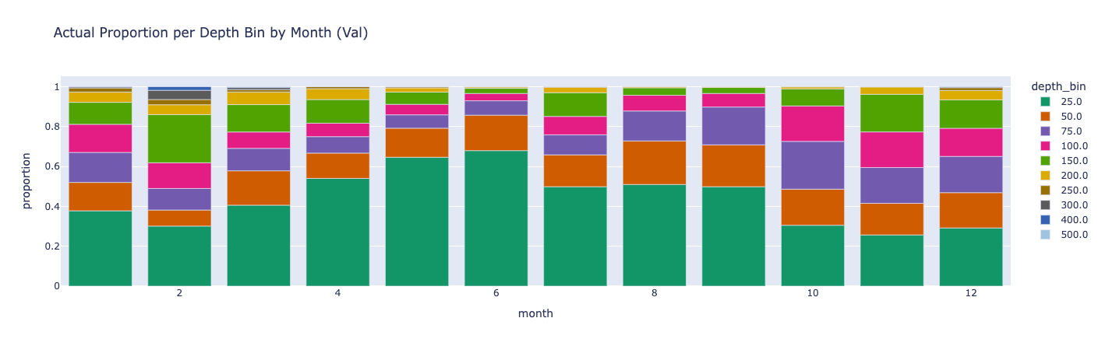
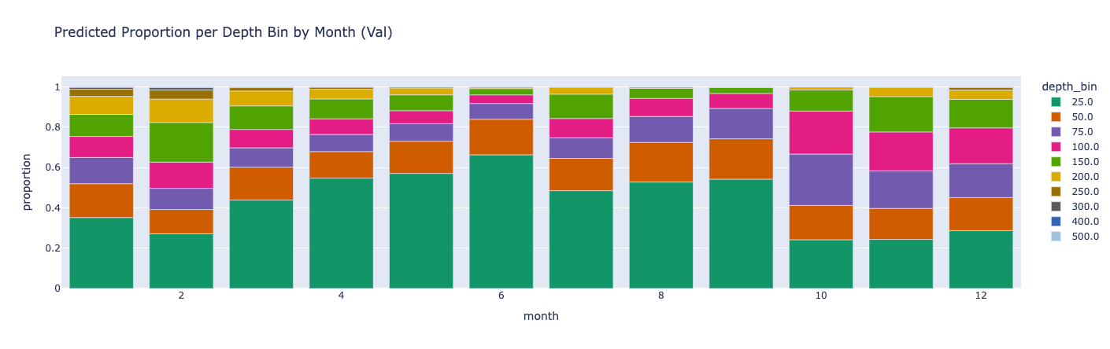
Figure 1: Seasonal Shifts in Depth Occupancy. (Top) Using observations of depth at 15-minute intervals from individual Chinook salmon (GOA and EBS), the proportions of samples in each depth bin across all months. (Bottom) For those same samples, mean predicted probability of the occupied depth from a deep learning model binned across all months.
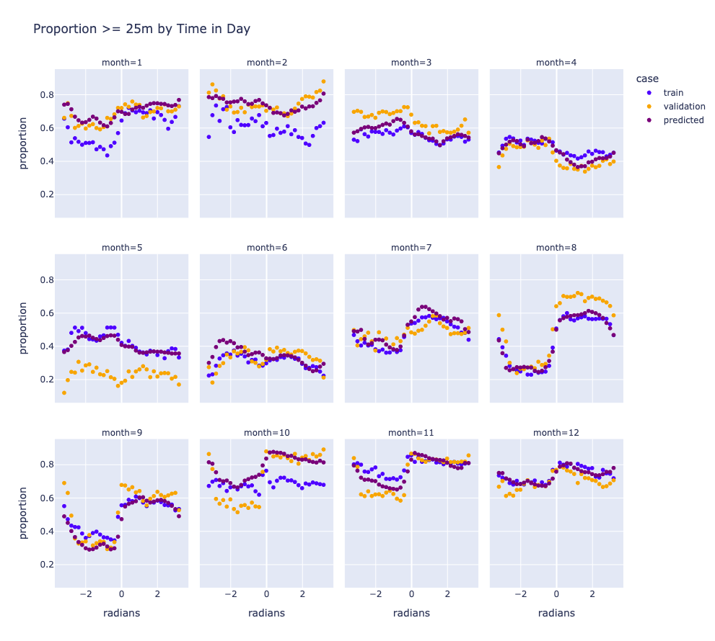
Figure 2: Diel Variation Using observations taken at 15-minute intervals from Chinook salmon in the GOA and EBS, the proportions of samples deeper than 25m as a function of time of day across all months. Validation is the proportion over the validation data, train is the proportion over the training data and predicted is the mean predicted probability of the occupied depth over the validation data.

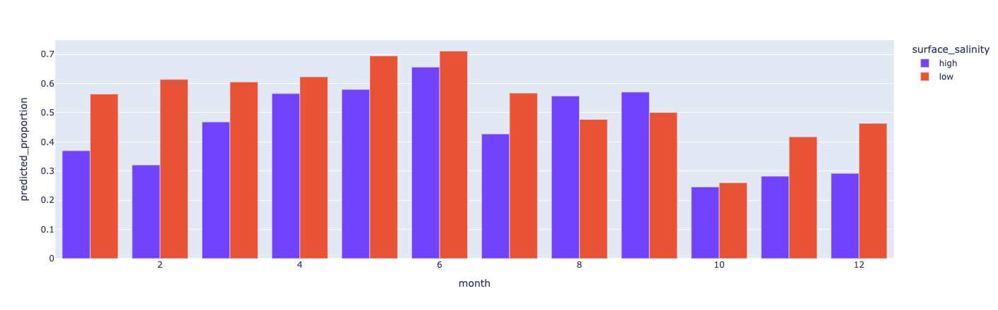
Figure 3: Effect of Salinity Using predictions of depth occupancy at 15-minute intervals for Chinook salmon using a deep learning model, predicted proportions of fish within 25m of the surface when surface salinity is above (high) and below (low) 31.3ppt. Predictions were made over the validation dataset.
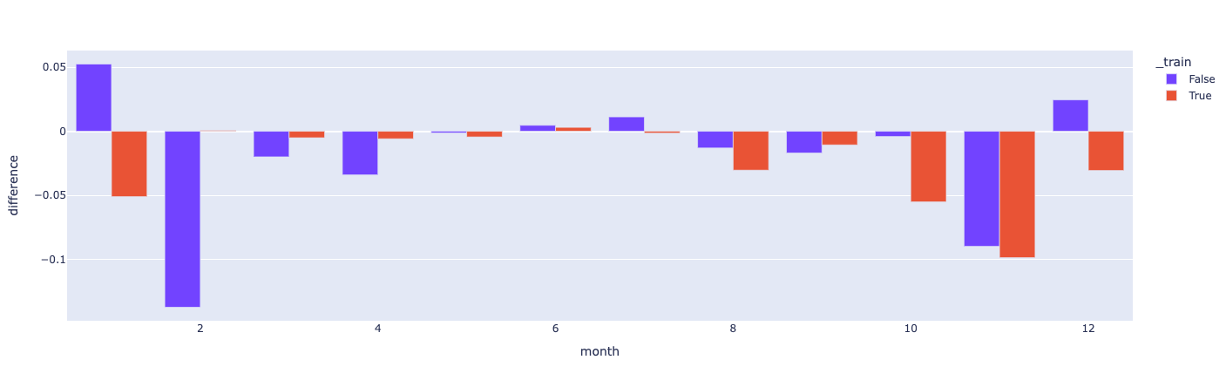
Figure 4: Variation in Performance of Salinity as a Feature Change in loss across months when adding salinity as a feature to a deep learning model of Chinook salmon depth occupancy. Red indicates the training dataset whereas blue indicates the validation dataset.

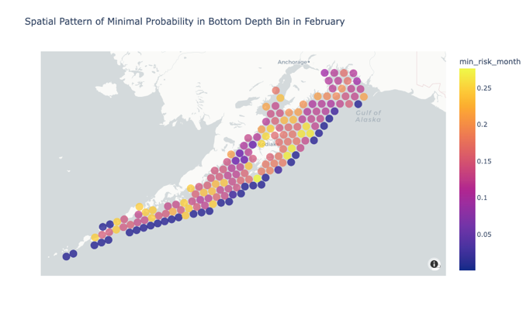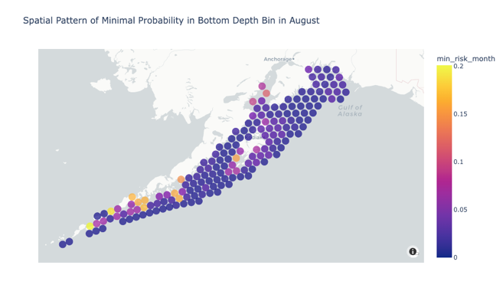
Figure 5: Spatial Distribution of Minimum Likelihood. Minimum likelihood of Chinook salmon occupancy in the deepest bin over each hour in the months of February (left) and August (right) as predicted by our deep learning model.
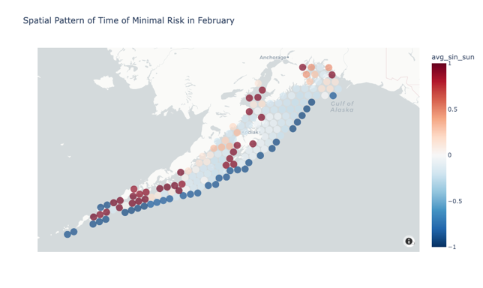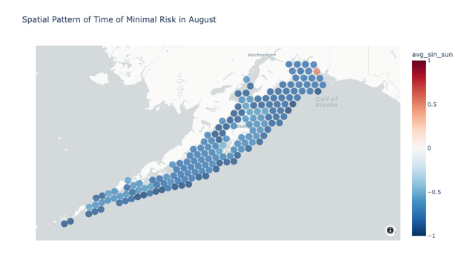
Figure 6: Time of Day Minimization. Time of day when the predicted likelihood, from our selected model, in the deepest bin for Chinook salmon is minimized on February (left) and August (right) 15. Negative values indicate nighttime whereas positive values indicate daytime.
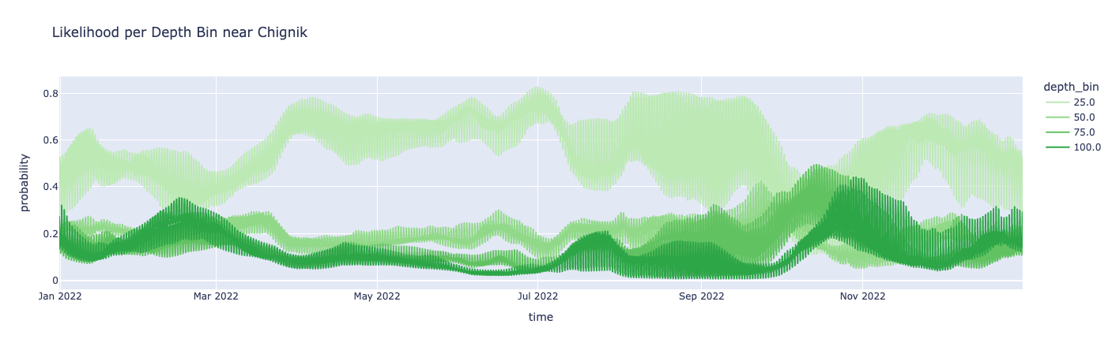
Figure 7: Full Year of Likelihoods Predicted likelihood, using our selected model, of occupancy per depth bin for Chinook salmon across all hours in 2022 for an H3 cell near Chignik, AK.

